Disease Surveillance and Early-Warning Platform-Early Warnings
Disclaimer: This project is primarily recommended for serious students; those without sufficient background or interest in advanced AI concepts may find it challenging.
Project Domain and Category
Machine Learning, Public Health Surveillance, Geographic Analytics, Web Application.
Abstract and Introduction
The Hospital-Connected Disease Surveillance and Early-Warning Platform is a proposed AI-powered public health system designed to connect hospitals, diagnostic laboratories, and district health departments. Hospitals will upload patient and laboratory records or automatically synchronize data through approved integrations. The platform will use Machine Learning (ML), geographic analysis, and surveillance rules to monitor malaria and typhoid, forecast case trends, identify potential hotspots, and generate alerts for district health officers.
The platform aims to help health teams identify unusual increases in reported cases, investigate affected areas, and prioritize response resources
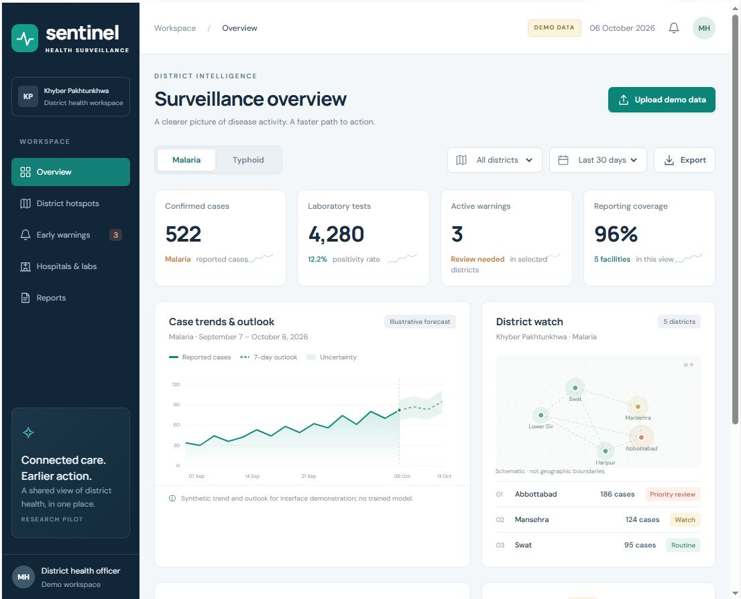
Figure 1
Functional Requirements
1 Data Collection and Preprocessing Module
- Collect approved records with dates, laboratory results, disease status, age bands, and district codes.
- Support validated CSV uploads and demonstrate automatic API synchronization using a mock hospital source.
- Handle missing values, duplicate submissions, invalid dates, inconsistent codes, and corrected results.
- Use pseudonymous identifiers, retain provenance, and define repeat-test and disease-episode counting rules.
- Aggregate suspected and confirmed cases separately; distinguish missing reports from zero cases.
- Prepare historical training and evaluation periods and show data-quality summaries without direct identifiers.
2 Machine Learning Model Training Module
- Train separate malaria and typhoid models to forecast district case counts for the following week.
- Compare historical and seasonal baselines with time-series, Transformer Base models
- Use lagged counts, calendar features, and reporting coverage; assess optional contextual data separately.
- Evaluate future held-out periods using MAE, RMSE, and interval coverage; compare results across districts.
- Save model versions, feature definitions, and evaluation results for reproducible dashboard integration.
3 Model Tuning and Optimization Module
- Tune models within training data using time-aware cross-validation and suitable search methods.
- Prevent leakage by excluding results and other information unavailable at the intended prediction time.
- Compare tuned models with baselines by disease and report uncertainty and limitations.
- Select models for forecasting reliability, calibration where applicable, and performance across locations.
- Monitor drift and reporting gaps; withhold forecasts when data quality or history is insufficient.
5 Web Based User Interface
- Provide a responsive web dashboard for hospital staff, analysts, and district health officers. Please check Figure 1
- Include malaria and typhoid others disease views with district, facility, period, and case-status filters.
- Display case summaries, testing activity, trends, hotspot maps, and forecasts with uncertainty intervals.
- Show upload validation, synchronization status, reporting completeness, and an actionable alert queue.
- Provide dataset summaries, model evaluation results, and consistently filtered aggregate report exports.
- Apply role-based access and privacy-conscious aggregation; label demo data and handle empty states.
6 Testing and Validation Module
- Test invalid uploads, duplicates, corrected results, missing reports, and delayed synchronization.
- Check totals and geographic assignments against controlled records and agreed case definitions.
- Measure alert precision, recall, false-alert frequency, and lead time against reviewed events.
- Test access boundaries, exports, acknowledgment, mobile layouts, and processing-error recovery.
- Document expected and actual results; require local validation and data-sharing agreements before a pilot.

Note: Please complete the following tasks:
- Complete all the functional requirements then.
- Develop the module outlined below (refer to Figure 1 for module details).

Proposed Tasks to Complete:
Module | Functions
Navigation | Overview, Malaria, Typhoid, Districts, Time span, Export file, Confirmed cases, active warning, Reporting coverage, Uploads & Sync, Display role-appropriate menus, the selected district, active-warning count, and data refresh time. Preserve selected filters when moving between screens. among others.
Filters | Disease, district, facility, date range, and case status among others.
Early Warnings | Predict future cases in districts, Prioritization, Alert generation, Configure disease- and district-specific warning thresholds. Generate alerts from observed increases and separately validated forecast signals. Assign severity using documented rules. Attach evidence and reporting coverage. Prevent duplicate alerts, assign responsible officers, track acknowledgment and investigation, escalate overdue actions, and record closure reasons. Maintain a complete alert history.

Tools
Python, pandas, NumPy, scikit-learn, Deep Learning models, statsmodels, FastAPI, Gradio, Stream lite, React, Leaflet, PostgreSQL with PostGIS, Matplotlib, Jupyter Notebook, Google Colab, VS Code, Git, and Docker.

GitHub Repository
You must create account in GitHub and follow this repository for latest update
https://github.com/dr-mushtaq/Water-borne-diseases.
Supervisor
Name: Dr. Mushtaq Hussain
Email ID: mushtaq.hussain@vu.edu.pk
Team ID: themushtaq48
References
[1] Hussain et al. Machine learning based efficient prediction of positive cases of waterborne diseases. BMC Medical Informatics and Decision Making, 23, 11 (2023). https://doi.org/10.1186/s12911-022-02092-1
[2] World Health Organization. Malaria fact sheet. https://www.who.int/news-room/fact-sheets/detail/malaria

